REPORT-TUTORIAL 1

Date: 23rd October 2013 Kartik Vermun(11CS30015)

Consider the following Grammar:
S' -> S
S -> CC
C -> aC
C -> d

- LR(1)

Our task is to construct the LR(1) sets of items for the above grammar. It can be done using the following 3 procedures which are interdependent on each other:

Set_Of_Items CLOSURE(I)
{
repeat
for ( each item [A -> α.Bβ, α] in I )
for ( each production B -> γ in G' )
for ( each terminal b in FIRST(βα) )
add [B -> .γ, b] to set I;
until no more items are added to I;
return I;
}

Set_Of_Items GOTO(I,X)
{
initialize J to be the empty set;
for ( each item [A -> α.Xβ, a] in I )
add item [A -> αX.β, α] to set J;
return CLOSURE(J);
}

void items(G’)
{
initialize C to CLOSURE({[S' -> .S, $]});
repeat
for ( each set of items I in C )
for ( each grammar symbol X )
if ( GOTO(I, X) is not empty and not in C )
add GOTO(I,X) to C;
until no new sets of items are added to C;
}

The first step is to construct the augmented grammer G’, then invoke items, which inturn will invoke GOTO and CLOSURE in order to construct the item set.

The following is the LR(1) set of items construction represented graphically:

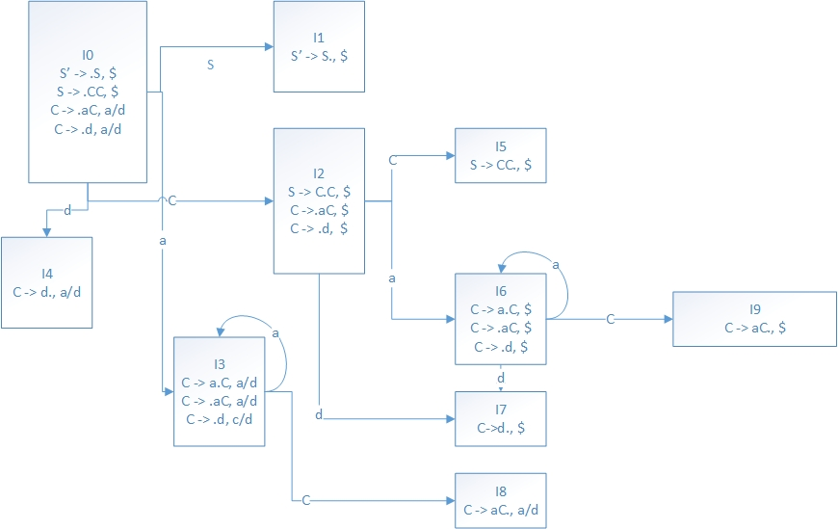

The following is the Action and the Goto function table as seen from the above Graph:

States | a | d | $ | S | C
0 | s3 | s4 |  | 1 | 2
1 |  |  | accepted
2 | s6 | s7 |  |  | 5
3 | s3 | s4 |  |  | 8
4 | r3 | r3
5 |  |  | r1
6 | s6 | s7 |  |  | 9
7 |  |  | r3
8 | r2 | r2
9 |  |  | r2

Clearly, the language of the Grammar is: a*da*d
Now we parse a string and show its implementation using 2 stacks.
Consider the following adad.

The following is the parsing table achieved via implementation of two stacks.

States | Symbol | Input | Action
0 | $ | adad$ | Shift S3
03 | $a | dad$ | Shift S4
034 | $ad | ad$ | Reduce C -> d
038 | $aC | ad$ | Reduce C -> aC
02 | $C | ad$ | Shift 6
026 | $Ca | d$ | Shift 7
0267 | $Cad | $ | Reduce C -> d
0269 | $CaC | $ | Reduce C -> aC
025 | $CC | $ | Reduce S -> CC
01 | $S | $ | accepted

- LALR

The LALR parsing table can be constructed using the LR table by implementing the following procedure:
1. Construct C = (I₀, I₁, ….. I_{N},), the collection of sets of LR(1) items.
2. For each core present among the set of LR(1) items, find all sets having that core, and replace these sets by their union.
3. Let C' = {J₀, J₁,. . . , J_{N},) be the resulting sets of LR(1) items. The parsing actions for state i are constructed from Ji in the same manner as done for LR(1). If there is a parsing action conflict, the algorithm fails to produce a parser, and the grammar is said not to be LALR(1).
4. The GOTO table is constructed as follows. If J is the union of one or
more sets of LR(1) items, that is, J = I_{l} ∩ I₂ ∩…. ∩I_{K}, then the cores of GOTO(I₁, X) , GOTO(I₂, X) , . . . , GOTO(I_{k}, X) are the same, since 1₁, 1₂, . . . , I_{k} all have the same core. Let K be the union of all sets of items having the same core as GOTO(I₁, X). Then GOTO(J, X) = K.

The following is the LALR ACTION and GOTO table construction for the same Grammar as used in LR(1) table construction.

STATE | ACTION |  |  | GOTO
 | c | d | $ | S | C
0 | s36 | s47 |  | 1 | 2
1 |  |  | Accepted
2 | s36 | s47 |  |  | 5
36 | s36 | s47 |  |  | 89
47 | r3 | r3 | r3
5 |  |  | r1
89 | r2 | r2 | r2

The following is the LALR item set construction as seen graphically:

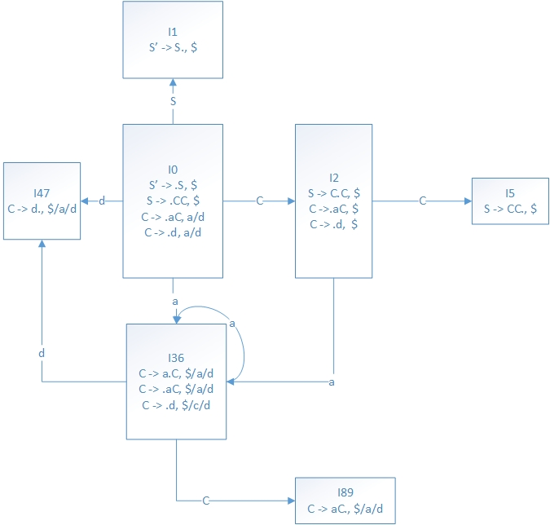

Questions:

Q1) Parse the string adad using the LALR parsing table and compare the stack sequence with the LR(1) parsing table.

Q2) Parse the invalid string aad using the LR(1) and LALR parsing table.

Q3) Design SLR,LR(1) and LALR for the following grammar:
S-> aBc|bCc|aCd|bBd
B-> e
C-> e
Q4) Design SLR,LR(1) and LALR for the following grammar:
S-> A
S-> xb
A-> aAb
A-> B
B-> x

