COMPILERS CS31003

Arpit Tarang Saxena, 11CS30005

Date: 9/10/2013

Differences between LR(1) and SLR :
SLR : [ A α · a β ]
LR(1): [ A α · a β, b ] where ‘b’ is the lookahead.

G1: SLR Grammar: SLR Table (No Conflicting entries)
G2: Non SLR Grammar.

LR(1) Automaton:
- Parse Table: Action, Goto
- State i, I_{i} ϵ [
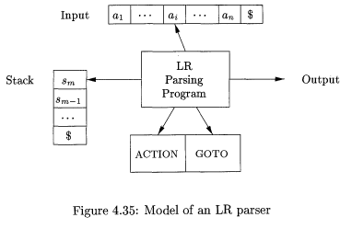
An LR Parser consists of an input, an output, a stack, a driver program, and a parsing table that has two parts: ACTION and GOTO. The driver program is the same for all LR parsers (including SLR); only the parsing table changes from one parser to another. The parsing program reads characters from an input buffer one at a time. Where the shift-reduce parser would shift a symbol, an LR parser shifts a state. Each state summarizes the information contained in the stack below it.

Structure of the LR Parsing Table:
The parsing table consists of two parts: a parsing function ACTION and a goto function GOTO.
- The ACTION function takes as arguments a state i and a terminal a (or $, the input end marker). The value of ACTION[i, a] can have one of four forms:
  - Shift j, where j is a state. The action taken by the parser effectively shifts input a to the stack, but uses state j to represent a.
  - Reduce A β. The action of the parser effectively reduces β on the top of the stack to head A.
  - Accept. The parser accepts the input and finishes parsing.
  - Error. The parser discovers an error in its input and takes some corrective action.
- Extend the GOTO function, defined on sets of items, to states: if GOTO[ I_{i}, A] = I_{j}, then GOTO also maps a state i and a nonterminal A to state j.

Comparison of Parsers:
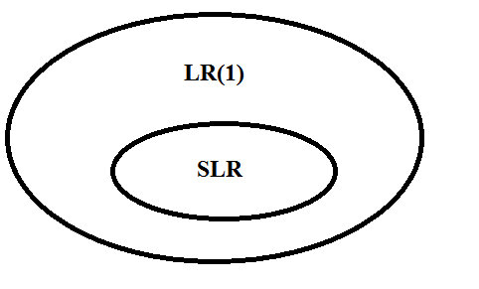

LALR Parsers:
Goal:
- Reduce the number of states in LR(1) parser.
- Keep the same grammar.
Construct Automata for LALR Parser:
- Construct LR(1) automata (parsing table)
- Core Items: Those that share the same derivations as the first component. Identify those states which share the same core. Aggregate these states.

